EXP. NO: 23
PERFORMANCE EVALUATION OF 8-QAM AND 16-QAM COMMUNICATION SYSTEMS UNDER AWGN USING BER, CONSTELLATION AND EYE DIAGRAM ANALYSIS IN MATLAB
Objectives:
1. To generate random binary data and implement 8-QAM and 16-QAM digital modulation in MATLAB.
2. To transmit the modulated signals through an Additive White Gaussian Noise (AWGN) channel for selected SNR/Eb/N0 conditions.
3. To evaluate the bit error rate (BER) performance of 8-QAM and 16-QAM and compare the measured results with the expected trend.
4. To plot and interpret the constellation diagrams of 8-QAM and 16-QAM under different noise conditions.
5. To generate and analyze eye diagrams to observe the effect of AWGN on signal quality and symbol/decision margins.
6. To compare the performance of 8-QAM and 16-QAM in terms of spectral efficiency, BER, constellation separation and eye opening.
Procedure:
1. Open the MATLAB software and create a new script file.
2. Clear the command window, workspace, and close all previously opened figure windows.
3. Generate a random binary data sequence.
4. Group the binary data into symbols and perform M-QAM modulation.
5. Transmit the modulated signal through an Additive White Gaussian Noise (AWGN) channel.
6. Demodulate the received M-QAM signal.
7. Compute the Bit Error Rate (BER) by comparing the transmitted and received binary data.
8. Display the transmitted and received constellation diagrams.
9. Generate the eye diagram of the received signal.
10. Execute the MATLAB program.
11. Observe the BER, constellation diagram, and eye diagram.
12. Analyze the communication system performance based on the BER value, constellation distribution, and eye opening.
PROGRAM :
clc;
clear;
close all;
% Parameters
M = 16; % 16-QAM
N = 1000; % Number of symbols
data = randi([0 M-1],N,1);
% QAM Modulation
tx = qammod(data,M,'UnitAveragePower',true);
% AWGN Channel
rx = awgn(tx,10,'measured'); % 10 dB SNR
% Demodulation
data_rx = qamdemod(rx,M,'UnitAveragePower',true);
% BER Calculation
[num, ber] = biterr(data,data_rx);
% Display BER
fprintf('Bit Error Rate (BER) = %f\n',ber);
% Eye Diagram Signal
eyeSig = repelem(real(rx),8);
% Plots
figure;
subplot(2,2,1)
scatter(real(tx),imag(tx),'filled')
title('16-QAM Transmitted Constellation')
grid on
subplot(2,2,2)
scatter(real(rx),imag(rx),'filled')
title('Received Constellation (AWGN)')
grid on
subplot(2,2,[3 4])
eyediagram(eyeSig,16)
title('Eye Diagram')
Output:
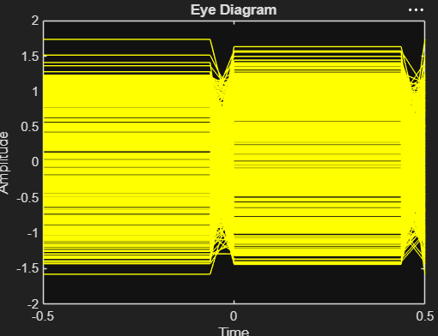
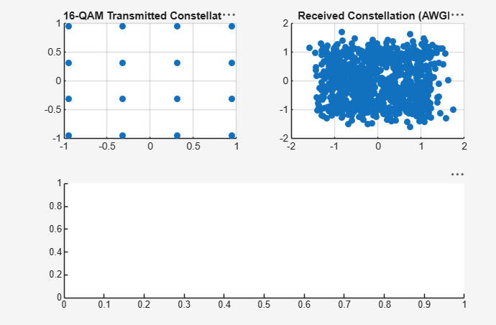
Result:
- Implemented 8-QAM and 16-QAM modulation and demodulation in MATLAB
2. Evaluated BER for different SNR/Eb/N0 values and interpret BER curves.
3. Analyzed constellation diagrams and identify the effect of AWGN on symbol dispersion.
4. Generated and interpret eye diagrams as a visual measure of signal quality.
5. Compared 8-QAM and 16-QAM based on BER, constellation quality and eye opening

